General Instructions:
- Total manuscript limit is 5000 words (including Abstract) and max of 75 References.
- Sentences cannot start with a number, unless the number is spelled out.
- No patient identifying information can be included.
- The manuscript sections should include Title, Abstract, Introduction, Methods, Results, Discussion, Conclusions, and References.
- A maximum of 3 Figures and / or Tables can be included within the manuscript per authors’ placement preference.
- Figures / Tables should be included within the body of the manuscript (multiple images can be included into a single figure.
- Figure legend should be not included in the Figure and should be separate word text below it.
- Table title or legend should be not included in the Table and should be separate word text above it.
- Use brackets for figure and table numbers in bold, e.g. [Table 1, Figure 1], both at the end of each sentence before the period.
- Use Times New Roman font size 12, Double-spaced lines, Use Continuous line numbering,
- et al. within the text should be italicized.
- Spell out all the abbreviations first time they appear in the Abstract and in the main text.

Figure Instructions:
- Figures should be embedded directly into the manuscript.
- Multiple images can be included into a single figure by pasting them into a Word document and saving as a JPEG file. Alternatively, applications such as Canva.com, PicCollage.com, and PhotoCollage.com can be used to create multi-image figures, for example, this is a single figure with two images: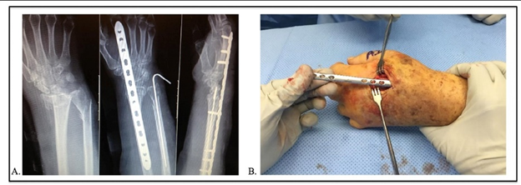
- The figure’s legend should be text written outside and below the figure it is referencing.

TITLE

ABSTRACT (300 words)
Objectives:
Methods:
Results:
Conclusion:
Keywords:
Level of Evidence: (Define an exact number for the level of evidence. https://www.ncbi.nlm.nih.gov/pmc/articles/PMC4671889/ )
INTRODUCTION
- 500 words
- The last lines of the Introduction should state the hypotheses and/or the aim of the study.
- Use Times New Roman font size 12, Double-spaced lines, Use Continuous line numbering,
- Use brackets for figure and table numbers in bold, e.g. [Table 1, Figure 1], both at the end of each sentence before the period.
- et al. within the text should be italicized.

METHODS
- 1000-1500 words
- You can use sub headers including Patients, Intervention, Statistical Analysis
- Table and figures must be inserted within the manuscript text where they belong.
- Place table titles and notes directly in the document, above or below the table. Table titles and notes should not be contained within tables.

RESULTS
- 500 words
- Start with responding to the hypotheses and aims stated at the end of the Introduction in the order they appear.
- Table and figures must be inserted within the manuscript text where they belong.
- Place table titles and notes directly in the document, above the table. Table titles and notes should not be contained within tables.
- Separate the label (“Table 1”) and title (“Title of Table 1”) by a period rather than a colon, e.g., “Table 1. Title of Table 1.”
- Add "gridlines" to the tables (Vertical and horizontal).
- Remove any styling (e.g., bold or italic font) applied to the title of tables and figures.
- When submitting charts as figures, insert the original format of the chart in the "Word" file, do not insert the jpeg format in the word file.
- Each figure should consist of exactly one JPEG, PNG, or TIFF file inserted into the docx. If a figure consists of multiple parts/pictures, they should all be combined into a single image. Note: Figures should not be left as Word objects (e.g., charts, graphs, etc.). If they are created using Word tools, they should be exported and re-inserted as images.
- Equations should be created using Word’s equation builder: https://support.microsoft.com/en-us/office/write-an-equation-or-formula-1d01cabc-ceb1-458d-bc70-7f9737722702
- Use Italic style for P values with CAPITAL P.

DISCUSSION
- 1000 words
- Discussion should include separate paragraphs, including a Restatement of the problem and the study’s findings, Limitations, Comparison with the literature, Synthesis of the comparison and the authors’ findings to arrive at a conclusion.

CONCLUSION
- Limit this section to one paragraph.
- No reference number should be cited in this section.

REFERENCES
- A maximum of 75 references is allowed.
- The reference style must be AMA style. Reference numbers must be superscript Arabic numerals. Use superscript numerals outside periods and commas, and inside colons and semicolons without space. References must be in numerical order in the text. Examples:
  - _The two largest studies to date included 35 patients² and 40 patients.³
  - _The derived data were as follows^{3,4}:
  - _As reported previously,^{1,3-8,19}

